

Course Name: Computer Graphics Fundamentals
Project Title: Interactive 3D Room Interior with Lamps — Topic 16
Team Members: Azamat Kuanyshpayev, IT-2514; Arsen Galym, IT-2510
Instructor: Kamila Batkuldinova
Date of Submission: 13 November 2026
Project Repository: https://github.com/Askomm/OpenGLRoom

Table of Contents
1. Introduction
2. Literature Review/Background
3. Project Description
3.1 Objective
3.2 Problem Statement
3.3 Scope
4. Technical Implementation
4.1 Tools and Technologies Used
4.2 Development Process
4.3 Algorithms and Techniques
5. Graphics and Rendering
5.1 2D/3D Rendering Techniques
5.2 Lighting and Shading
5.3 Texturing and Animation
6. Testing and Evaluation
6.1 Testing Methodology
6.2 Performance Evaluation
6.3 Issues and Debugging
7. Conclusion and Future Work
8. References

1. Introduction
This project develops an interactive furnished room using modern OpenGL. It began as a small Week 5 demonstration with a floor, walls, a table, a cabinet, two lamps and a first-person camera. The final version expands that starting point into a study and sleeping area with a bed, chair, books, vase, three independently controlled lamp fixtures, a window, day and night modes, direct sunlight, shadow mapping, exposure control and a compact on-screen help panel.
The project is relevant to computer graphics because it brings the rendering pipeline into one scene that can be explored in real time. Object transformations determine the position and scale of furniture; camera matrices control the view; programmable shaders calculate surface illumination; depth textures describe visibility from light sources; and keyboard and mouse input change the rendered result while the application is running.
The midterm build already demonstrated OpenGL 3.3 Core, procedural meshes, a perspective camera, mouse look, scroll zoom, two point lights, emissive bulbs and a checker pattern. Those elements formed the foundation for the final stage. The final implementation retains the interactive camera and shader-based rendering while replacing the two-lamp scene with a more complete interior, a third moving pendant, wood and fabric patterns, a textured window view and daytime sunlight.
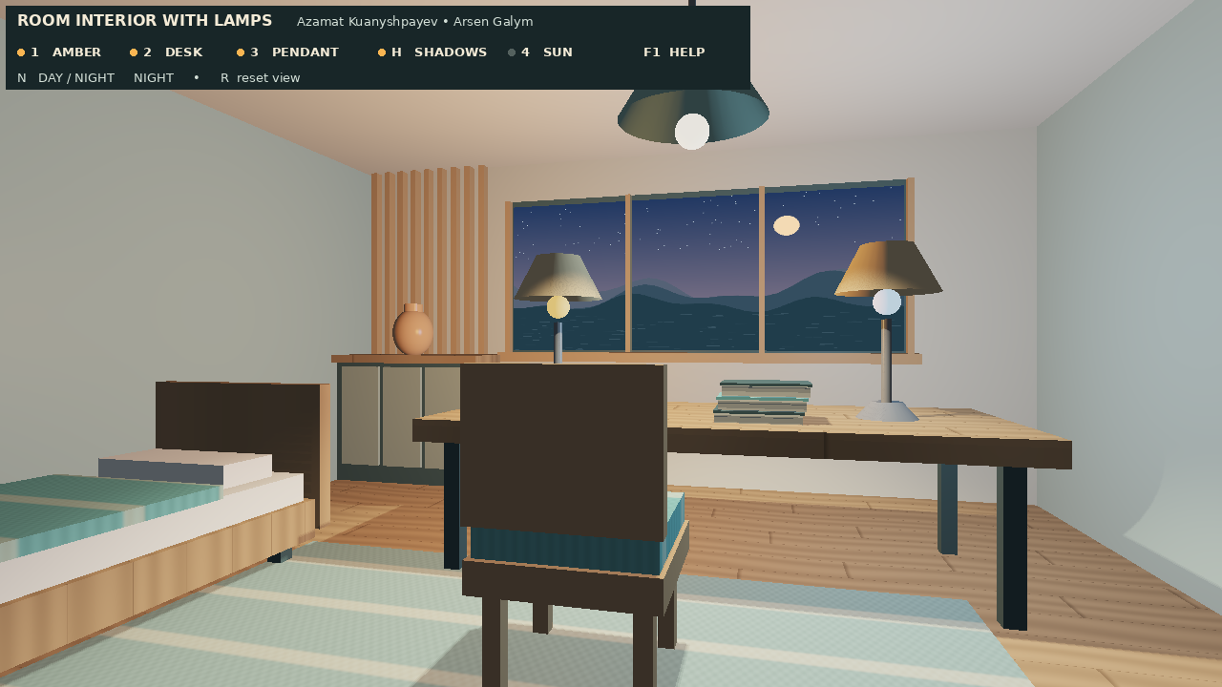
Figure 1. Final night scene with the bed along the left wall, shifted desk and three lamp fixtures.
Figure 1 illustrates the final room arrangement and the on-screen control panel. The bed and desk are separated by a wider aisle, and the pendant is visible above the central workspace.

1.1 Motivation and Expected Outcomes
The room was selected because lighting and materials can be evaluated immediately by changing a lamp, moving the camera or comparing day and night. The expected outcome was a buildable, interactive OpenGL application that demonstrates transformations, rasterization, Phong illumination, material variation, mapped shadows, texture sampling and user interaction. The final repository contains these systems and documents the remaining verification boundary: the updated application was exercised with Mesa llvmpipe, while a native Windows run of the latest bed/daylight revision remains to be completed.

2. Literature Review/Background
The project’s implementation background is based on the LearnOpenGL tutorial series. The midterm report used LearnOpenGL to introduce the modern programmable pipeline, vertex data, Model–View–Projection transformations, camera orientation and basic lighting. The final implementation extends those concepts with multiple light sources, material parameters, texture sampling and depth-based shadows. The ten links below are the practical references used to organize the implementation and explain the techniques.
Hello Triangle: https://learnopengl.com/Getting-started/Hello-Triangle
Introduces the graphics pipeline, vertex data, VAOs, VBOs, element buffers and indexed triangle drawing. The project uses indexed procedural meshes for room and furniture geometry.
Shaders: https://learnopengl.com/Getting-started/Shaders
Explains programmable vertex and fragment shaders. The project loads GLSL files from the shaders directory and sends matrices, light data and material uniforms.
Transformations: https://learnopengl.com/Getting-started/Transformations
Provides the model transformation concepts used to position and scale reusable primitive meshes.
Coordinate Systems: https://learnopengl.com/Getting-started/Coordinate-Systems
Explains model, view and projection spaces. The room uses model, camera view and perspective projection matrices.
Camera: https://learnopengl.com/Getting-started/Camera
Covers camera basis vectors, yaw/pitch mouse control and keyboard movement. These concepts underpin the walkthrough camera.
Basic Lighting: https://learnopengl.com/Lighting/Basic-Lighting
Introduces ambient, diffuse and specular lighting. The final fragment shader uses ambient plus diffuse and reflection-vector specular terms.
Materials: https://learnopengl.com/Lighting/Materials
Describes material properties and shininess. The project varies specular response to distinguish fabric, wood, ceramic and lamp surfaces.
Lighting Maps: https://learnopengl.com/Lighting/Lighting-maps
Discusses texture maps for material response. The room instead uses shader-generated wood/fabric patterns and a sampled PPM landscape image.
Multiple Lights: https://learnopengl.com/Lighting/Multiple-lights
Explains combining multiple light contributions. The final shader evaluates three independently toggled positional lamps.
Shadow Mapping: https://learnopengl.com/Advanced-Lighting/Shadows/Shadow-Mapping
Explains depth maps from a light viewpoint and depth comparisons in the camera pass. The project uses this method for the pendant and sun.
The tutorial material is used as implementation background, not as a claim that every technique shown in the tutorial series is implemented. In particular, this project does not implement physically based Cook–Torrance shading, ray tracing, a cubemap reflection system or a general-purpose physics engine.

3. Project Description

3.1 Objective
The objective is to create an interactive room interior in OpenGL 3.3 Core where the user can walk through the furniture layout, inspect materials, toggle each of the three lamps, move or animate the ceiling pendant, compare night lighting with daylight, and enable or disable mapped shadows. The scene also serves as a compact demonstration of the model-view-projection pipeline and forward fragment shading.

3.2 Problem Statement
The main challenge is to keep multiple representations of the same scene consistent. The visible lamp meshes, shader light positions, light-space depth rendering and camera collision bounds must refer to the same geometry and coordinates. A mismatch can cause a detached shadow, illumination from an incorrect position or camera movement through furniture. A second challenge is making visual comparisons reproducible: each major light or shadow feature must be independently controlled, and the application must provide a stable reset state.

3.3 Scope
Included area | Final implementation / boundary
Room and furniture | Floor, walls, ceiling, window, bed, desk, chair, cabinet, books, vase, rug and three lamp fixtures.
Lighting | Three positional lamp sources and a fixed directional sun enabled in day mode.
Shadows | Two 1024 × 1024 depth maps: one for the pendant and one for the sun. The two desk lamps do not have mapped shadows.
Camera and interaction | First-person eye-height walkthrough, mouse look, wheel zoom, rectangular XZ collision, light toggles, pendant movement, exposure and reset.
Materials and textures | Phong-style lighting, procedural wood/fabric patterns, PPM day/night window images and a textured HUD.
Outside the scope | Ray tracing, indirect illumination, physically based rendering, general physics, imported furniture models and physically accurate area-light penumbrae.

3.4 Final Scene Layout
The final scene places the bed against the left wall. The desk group, chair, books and both desk lamps are shifted by 0.8 scene units along the X axis. This increases the visible gap between the bed headboard and desk from approximately 0.14 to 0.94 scene units. These are scene-space measurements, not dimensions in real-world metres. The shared DeskOffsetX constant in src/SceneLayout.h is reused by furniture placement, desk-light positions and camera bounds so that the visible room and collision behavior stay aligned.

4. Technical Implementation

4.1 Tools and Technologies Used
The application is written in C++20 and targets OpenGL 3.3 Core. GLSL 330 is used for the main vertex and fragment shaders and the depth-only shadow shaders. GLFW creates the window, manages the OpenGL context and supplies keyboard and mouse input. GLAD loads OpenGL entry points. GLM provides vector and matrix operations. CMake configures the Visual Studio build. GitHub stores the source and supports collaboration.
Technology | Role
C++20 | Application logic, procedural geometry, input, camera and render loop.
OpenGL 3.3 Core / GLSL 330 | Indexed mesh rendering, depth testing, shader-based lighting, texture sampling and shadow maps.
GLFW | Window and context creation; keyboard, mouse and scroll input.
GLAD | Loading OpenGL function pointers.
GLM | Vector operations, transformations, look-at view and perspective projection.
CMake / Visual Studio | Windows project generation and compilation.
Git / GitHub | Version control and integration of team contributions.

4.2 Development Process
Development began with the midterm baseline: an OpenGL window, shader program, procedural room primitives, two desk lamps, a camera class and basic input. The work was then extended in stages. The renderer stage introduced the shader, materials and lighting; the application stage assembled the furnished room, geometry, camera and controls. Later changes added the bed, directional sunlight, day/night switching and the wider aisle. Git commits and patches were used to combine changes while retaining the ownership of the main modules.
Integration checks focused on shared geometry and state. The same scene drawing path is used for the visible color pass and the light-space depth passes. A shared desk offset avoids separate edits to furniture, lamp positions and collision bounds. The repository README records the build procedure, runtime controls and the distinction between historical measurements and the updated final scene.

4.3 Algorithms and Techniques
Each object is transformed from local coordinates into world coordinates with a model matrix. The camera produces a view matrix with glm::lookAt, and a perspective projection matrix uses the current framebuffer aspect ratio and camera field of view. The vertex shader transforms positions and applies the inverse-transpose of the model matrix to normals, which preserves normal directions when furniture uses nonuniform scaling.
The main vertex transformation is:
FragPos = vec3(model * vec4(aPos, 1.0));
Normal = mat3(transpose(inverse(model))) * aNormal;
gl_Position = projection * view * vec4(FragPos, 1.0);
The camera stores Front, Right and Up vectors. Mouse offsets update yaw and pitch, with pitch limited to ±89 degrees. The mouse wheel changes the field of view between 25 and 75 degrees. WASD movement is projected onto the horizontal plane and the camera eye remains at 1.68 scene units. Collision checks the candidate XZ location against room limits and rectangular obstacle regions. When a candidate position enters a blocked region, the previous position is restored. This is a compact walkthrough constraint, not a general continuous collision system.
Key toggles use press-edge detection so that holding a key does not repeatedly invert a state. Continuous actions such as movement, exposure adjustment and pendant movement use elapsed frame time. The pendant moves horizontally when J or L is held; Space starts or pauses automatic motion, and the direction reverses at the end of its travel interval.

5. Graphics and Rendering

5.1 2D/3D Rendering Techniques
The room is rendered as indexed triangles. A small set of reusable procedural meshes (cube, cylinder, tapered frustum and sphere) is combined with model transforms to form walls, floor, desk parts, bed, chair, lamps and decorations. Vertex positions and normals are stored in vertex buffers, while index buffers specify triangle connectivity. The scene uses depth testing and back-face culling; selected open lamp shades are rendered two-sided where necessary.
The render loop updates input and animation, computes camera and light matrices, optionally renders the pendant depth map and daytime sun depth map, renders the room from the camera into the color buffer, and finally draws the HUD as a screen-space overlay with scene depth testing disabled. This separation keeps the 3D scene and 2D interface responsibilities distinct.

5.2 Lighting and Shading
The final fragment shader implements forward Phong shading. It begins with ambient illumination multiplied by the base material color. For each active positional light it computes a normalized light direction, distance attenuation, diffuse response and a view-dependent specular highlight. The specular term uses the reflection vector R and viewing direction V; this is the reflection-vector Phong model, not the Blinn–Phong halfway-vector variant described in the midterm report.
The key equations in the current shader are:
attenuation = 1.0 / (1.0 + 0.10*d + 0.032*d*d);
diffuse = max(dot(N, L), 0.0);
specular = pow(max(dot(reflect(-L, N), V), 0.0), shininess);
The amber desk lamp, cool desk lamp and ceiling pendant are independent positional sources. Their intensities become zero when their corresponding toggles are disabled. Emissive bulb geometry visually indicates an active lamp, while the separate positional-light calculation illuminates nearby surfaces. The pendant uses a downward smooth angular falloff so that its illumination is concentrated beneath the fixture. Day mode adds a fourth source: fixed directional sunlight passing through the window. It is not a fourth toggled lamp; it is controlled by the day/night state and key 4.

5.3 Shadow Mapping
The pendant uses a 1024 × 1024 depth texture with a perspective light projection. The sun uses a second 1024 × 1024 depth texture with an orthographic projection appropriate for parallel rays. In the camera color pass, a world-space fragment is transformed into light clip space, remapped to texture coordinates and compared with the stored light-space depth. A 3 × 3 neighborhood of comparisons is averaged to soften jagged shadow edges. A slope-dependent depth bias reduces self-shadowing (shadow acne).
Direct sunlight is additionally limited by an analytical window-aperture test. A ray from the surface toward the sun is intersected with the window plane; the contribution is accepted only if the intersection lies inside the opening and avoids the two wooden mullions. The sun depth pass then provides visibility from furniture. Room enclosing surfaces and the landscape panel are omitted from this depth pass because the aperture test handles their visibility. Night mode disables sunlight and skips its depth pass.

5.4 Texturing and Animation
Wood is generated procedurally in world space using plank seams and sinusoidal grain. Fabric uses a higher-frequency weave and broader stripes. These patterns are evaluated in the fragment shader and reused on the rug, chair and bed cover. The window samples project-generated PPM images for day and night; the landscape is an unlit background panel rather than a reflection or outdoor 3D scene. The HUD also uses PPM textures for the status and help panels.
The pendant position is updated from elapsed time during automatic motion or from the J/L keys during manual motion. The light position and visible fixture use the same state variable, keeping the bulb and illumination aligned. Day/night is a discrete lighting-state switch, not a simulated sun orbit. Exposure scales the accumulated lighting before the global tone curve C/(1 + C), followed by an approximate gamma conversion with exponent 1/2.2.
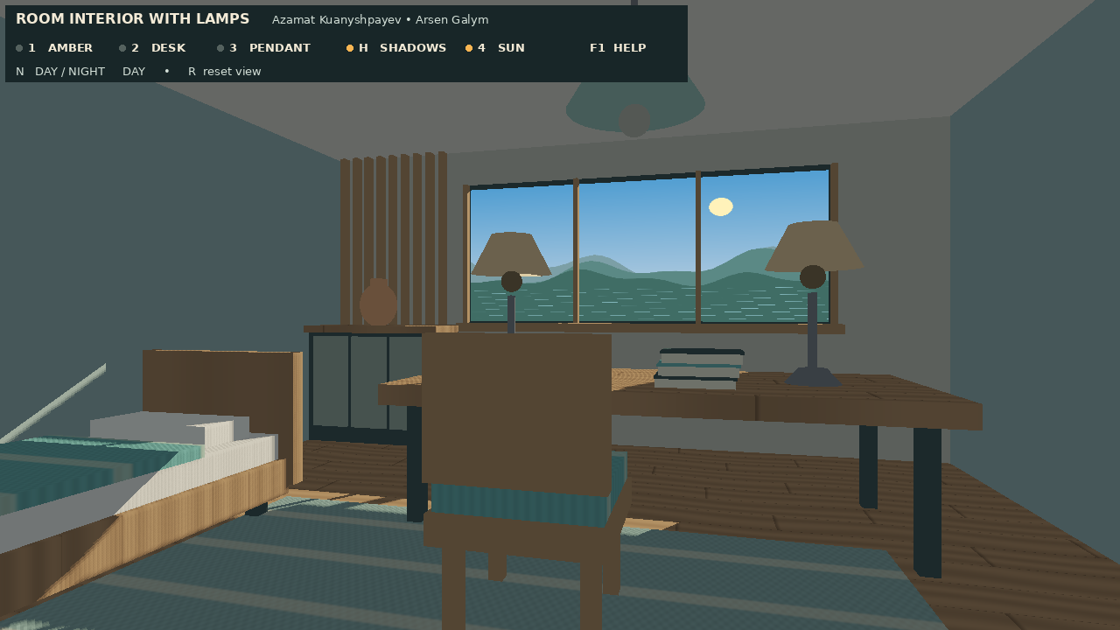
Figure 2. Day mode with the three lamps disabled, showing directional sunlight through the window.
Figure 2 illustrates the sun contribution without the three positional lamp contributions. Key 4 toggles direct sunlight while retaining daylight ambient illumination; H toggles the shadow maps and N returns to night mode.

6. Testing and Evaluation

6.1 Testing Methodology
Validation combined compilation, shader execution, scripted interaction checks, camera regression checks and visual inspection. The updated renderer was compiled and exercised in a Mesa llvmpipe OpenGL environment using scripted GLFW inputs. The checks included day/night switching, sunlight toggling, shadow toggling, reset behavior, held-key edge behavior, pendant movement, exposure adjustment and movement through the aisle. The earlier renderer stage had previously been built on Windows/MSVC.
The current report and README explicitly distinguish this evidence from a final native Windows acceptance test. The complete bed/daylight revision still needs to be launched on the Windows presentation computer, and its physical keyboard/mouse behavior and window-resize behavior should be checked there. No controlled participant study or questionnaire was conducted.
Test area | Observed result / remaining work
C++ and GLSL execution | Updated renderer compiled and executed with no reported OpenGL errors in the Mesa llvmpipe test environment.
Lighting and reset | Day/night, sun, shadow and reset states were checked with scripted input.
Camera and aisle | Camera passed through the widened aisle; the bed and shifted desk continued to block movement.
Demo rendering | 2,400 frames were rendered at 1280 × 720 for a 100-second, 24 fps demo video.
Windows acceptance | Earlier renderer stage built on Windows/MSVC; updated native Windows runtime, resize and physical input checks remain.
User evaluation | No formal user study or questionnaire was carried out.

6.2 Performance Evaluation
The repository README and final report record historical llvmpipe measurements for the earlier three-fixture version: 80.3 FPS with pendant shadow mapping and 101.9 FPS without it at 1280 × 720. Each run used 15 warm-up frames and 80 measured frames. These figures are historical and must not be treated as measurements of the current day/night revision, which adds a second depth pass for sunlight. The 24 fps value used for the encoded demo video is a playback setting, not an application FPS benchmark.
Current Windows FPS, CPU memory use and total GPU memory have not been measured. The two 1024 × 1024 depth textures contain a nominal 6 MiB of 24-bit depth payload in total; actual allocation can be larger due to driver storage and padding. A reproducible performance test should hold the screen resolution, camera position and frame count constant while comparing night/day and shadows on/off on the target defence computer.

6.3 Issues and Debugging
The main integration issue was maintaining alignment between furniture, light coordinates and collision bounds after widening the aisle. A shared DeskOffsetX constant corrected this by moving the desk group, desk lamps and collision region together. Shadow acne and jagged edges were reduced with depth bias and nine-sample filtering; excessive bias can detach a shadow, so it must remain small. Inverse-transpose normal transformation prevents incorrect lighting after nonuniform scaling. Shader compilation and linking diagnostics are printed by the shader loader, and framebuffer completeness is checked for both depth-map framebuffers.
The previous Windows build reported C4100 unused-parameter and LNK4099 missing GLFW PDB warnings, but the executable linked. The updated final application’s native Windows runtime check remains outstanding. The camera collision approach is intentionally simple: diagonal movement is not normalized and the camera stops rather than sliding along furniture. These limitations are recorded rather than presented as solved physics behavior.

7. Conclusion and Future Work
The final project develops the midterm room prototype into a complete interactive furnished interior. The result combines procedural indexed geometry, a first-person camera, three independently controlled lamps, directional daylight, two shadow maps, procedural wood and fabric materials, day/night window textures, tone mapping, exposure control and an on-screen guide. The progression from the midterm two-lamp scene to the final bed-and-desk layout shows how a small OpenGL demonstration can be extended while retaining a clear and explainable rendering architecture.
The implementation meets the central Topic 16 scene requirements visible in the repository: a walkable furnished room, at least three toggleable lamps that illuminate the room, material variety including glossy/emissive surfaces, a mapped shadow from a lamp and exposure/tone mapping. The outstanding acceptance work is to run the updated build on the Windows presentation machine and measure its performance there.

7.1 Team Contributions
Team member | Responsibility
Azamat Kuanyshpayev — IT-2514 | OpenGL initialization, shader system, vertex/fragment shader work, model-view-projection pipeline, Phong lighting, materials and lamp behavior. Later additions include the bed, directional sunlight, day/night controls and wider-aisle integration.
Arsen Galym — IT-2510 | Original furnished room and furniture, lamp geometry, procedural scene construction, textures, camera, mouse/keyboard controls, interaction and scene organization.
Both teammates | Git integration, review, testing, report, slides, speech preparation and final demonstration. Both are responsible for understanding and verifying the final application.

7.2 Limitations and Future Work
The next priority is a native Windows run of the latest repository revision on the defence machine, followed by a repeatable FPS measurement at the target resolution. Collision could be improved with normalized diagonal movement, sliding along obstacles and swept collision tests. Window dimensions and aperture parameters could be moved into shared scene configuration to avoid duplicated constants. Visual extensions include shadow maps for the two desk lamps, improved antialiasing, physically softer shadows, calibrated exposure and a physically based microfacet material model. These are future improvements, not current features.

7.3 Acknowledgment of Assistance
The project documentation records the use of AI coding assistance during implementation, integration, documentation, scripted validation and presentation preparation. The listed module responsibilities describe team ownership and defence roles; they do not imply that every line was authored without assistance. Both teammates remain responsible for reviewing the repository and being able to explain the shaders and rendering pipeline.

8. References
The References section is intentionally limited to LearnOpenGL links, as requested. The links below are the ten tutorial chapters used as practical background for the project.
Hello Triangle. https://learnopengl.com/Getting-started/Hello-Triangle
Shaders. https://learnopengl.com/Getting-started/Shaders
Transformations. https://learnopengl.com/Getting-started/Transformations
Coordinate Systems. https://learnopengl.com/Getting-started/Coordinate-Systems
Camera. https://learnopengl.com/Getting-started/Camera
Basic Lighting. https://learnopengl.com/Lighting/Basic-Lighting
Materials. https://learnopengl.com/Lighting/Materials
Lighting Maps. https://learnopengl.com/Lighting/Lighting-maps
Multiple Lights. https://learnopengl.com/Lighting/Multiple-lights
Shadow Mapping. https://learnopengl.com/Advanced-Lighting/Shadows/Shadow-Mapping

9. Appendix

9.1 Build and Launch (Windows)
The repository README specifies a Windows 10 or 11 environment with Visual Studio 2026 (or Visual Studio 2022 with its matching CMake generator), the Desktop development with C++ workload, CMake and an OpenGL 3.3-capable graphics driver. From the project root, use the appropriate generator:
cmake -S . -B build -G "Visual Studio 18 2026" -A x64
cmake --build build --config Debug
.\build\Debug\OpenGLRoom.exe
For Visual Studio 2022, use the Visual Studio 17 2022 generator. The repository bundles GLAD, GLM and an x64 Windows GLFW 3.5.1 static library. CMake copies shaders and textures beside the executable; keep these folders there when moving the executable. The repository CMake configuration explicitly targets Windows because the supplied GLFW library is a Windows binary.

9.2 Demonstration Controls
Input | Action
W / A / S / D | Walk; room boundaries and furniture block movement.
Mouse / wheel | Look around / change field of view.
1 / 2 / 3 | Toggle amber desk lamp / cool desk lamp / pendant.
N / 4 | Switch day/night / toggle direct sunlight during daytime.
H | Toggle pendant and sun shadow maps.
J / L; Space | Move pendant manually / start or pause automatic pendant travel.
− / = | Decrease / increase exposure.
R / F1 / Esc | Reset the scene / show help / exit.

9.3 Suggested Live Demonstration
• Press R to restore the initial night view and show the room layout and widened aisle.
• Press 1, 2 and 3 to isolate each lamp and compare the different colors and lighting contributions.
• Press H to compare pendant shadow mapping on and off while observing shadows on the furniture.
• Hold J or L to move the pendant; press Space to start or pause automatic travel.
• Hold − and = to demonstrate exposure control, then press R to restore the default settings.
• Press N for daytime, disable lamps 1–3 and observe the directional sunlight through the window.
• Press 4 to toggle direct sunlight while keeping daylight ambient light; press H to compare sun shadows.

9.4 Repository Structure and Key Modules
Path | Purpose
src/Main.cpp | Creates the OpenGL context and procedural meshes; manages input, lamp and pendant states; executes depth, color and HUD passes.
src/Shader.cpp / Shader.h | Loads GLSL files, compiles and links programs, reports diagnostics and sets shader uniforms.
src/Camera.cpp / Camera.h | Implements view matrix, mouse look, scroll zoom, movement and collision.
src/Interior.h | Assembles room geometry, furniture, bed, chair, books and vase.
src/SceneLayout.h | Defines the shared desk offset used by geometry, lamp positions and collision.
shaders/vertex.glsl and fragment.glsl | Transform geometry, shade materials, evaluate lamps and sunlight, test shadow visibility and tone-map the color.
shaders/shadow.vert and shadow.frag | Depth-only shadow rendering for the pendant and sun.
textures/ | Day and dusk landscape images, status/help panels and font license information.

